Insurance Selling Control

Business Requirement

Document no.:
Project: | Insurance Selling Control
Prepared by: | Pathompong Na-Songkhla
Date Issued: | 20/10/17
Project Manager: | Paisarn Jansiripong

Ownership and copyright in this document at all times belongs to Ayudhya Capital Auto Lease. It is supplied on the basis that its contents are at all times kept strictly confidential. This specification (or any part of it) shall not be copied or reproduced in any way without prior permission. This specification (or any part of it) shall not be disclosed to any third party and Ayudhya Capital Auto Lease shall take all such steps, as it considers necessary to protect its rights in the event of any unauthorised use.

Document History

Version no. | Modified Date | Modified By | Detail of changes
1 | 20/10/17 | Pathompong Na-Songkhla

Contact Persons

Pathompong Na-Songkhla
Sales and Distribution - SFE and Sales Development
Pathompong.Na-Songkhla@krungsri.com
02-708-8435

Approval Signatures

Document approval will be obtained through document circulation and a formal walk through and request for signoff.

What Sign-Off will approve

Business Sign-off

The purpose of sign-off, should it be given, is to approve:

- The requirements as documented are accurate, ie- consistent with the signatory’s understanding of the project requirements,
- That the solution proposed is suitable, ie- is cost-effective, timely, and achievable,
- That the project initiative is still of sufficient priority to progress to the development stage.

Technical Sign-off

The purpose of sign-off, should it be given, is to approve:

The requirements as documented are clearly understood and meet the architectural strategy of the technical team.

Testing Sign-off

From a testing perspective the purpose of sign-off, should it be given, is to approve:

The requirements are clearly documented and provide sufficient detail to allow testing of the stated requirements.

IT Project Manager Sign-off

The purpose of sign-off, should it be given, is to approve:
- That the correct IT groups have been identified and engaged in the sign-off process,
- That the IT Project Manager will manage execution of IT deliverables according to the Functional Specification.

Table of Contents

1 Document Information 5
1.1 Document Objective 5
1.2 Document Cross Reference 5
1.2.1 Business Specification 5
1.2.2 Related Functional Specification 5
1.2.3 Other related documents 5
1.3 Abbreviations and definitions 5
1.4 Document audience 6
2 Project Information 7
2.1 Project overview 7
2.2 Problem statement 7
2.3 Project Scope 7
2.4 Area Impact 7
3 Proposed solution 8
3.1 Business overview 8
3.2 Proposed system 19
4 Functional Requirements 20
4.1 AS-IS process flow 20
4.2 SHOULD BE process flow 20
4.3 Detailed Functional Requirements 20
4.3.1 Screen Requirements 20
4.3.2 Report Requirements 21
4.3.3 Compliance Requirements 31
4.3.4 Performance Requirements 31
4.3.5 GL Mapping 31
4.3.6 Security and Capacity Requirements 31
5 System impacts 31
5.1 Database impacts 31
5.1.1 Data Structure Change 31
5.1.2 Data Conversion 31
5.2 Parameters impacts 31
5.3 Communication impacts 31
5.3.1 Interface requirements 31
5.4 Infrastructure impacts 31
5.5 Other related platform impacts 32
6 General Consideration 33
6.1 Physical/ Layout Requirement 33
6.2 Equipment and tools Requirement 33
6.3 Human Resource consideration 33
6.4 Training Requirements 33
6.5 Disaster Recover Plan/ Business Continuity Plan/ Crisis Management Plan 33
7 FMEA/ Risk Analysis 34
7.1 Security Risk Analysis 34
8 Financial business case 35
9 Glossary of Terms 36
10 Appendix A 37

1 Document Information

Document Objective

This document illustrates the business and functional requirements for the Insurance selling Control project initiative. The purpose is to clearly provide:

1) Relevant project background information.
2) The Scope of work to be done.
3) Separate business and functional requirements that drive and support the required solution.
4) Relevant Reference information.
5) IT with the required documentation to commence work on Technical Specifications and Development.
6) QTC with required documentation to develop Test Strategy.
7) Project Manager with the detail required to develop the Implementation Plan and detailed project plan.

Please note that the business specification and the functional specification are interdependent and should be read in conjunction with one another.

Document Cross Reference

Business Specification
Attached related Business specification file.

Related Functional Specification
Attached related functional specification file.

Other related documents
Attached related documents file.

Abbreviations and definitions
[Shows the important abbreviation and definitions]

Abbreviations | Stand for

Document audience

Listing below is the distribution names for this project.

Department | Persons

Acknowledge Persons

Department | Persons

Project Information
In order to serve current business requirement, Insurance selling control system modification will be performed by a parts of requirements from Sales and Distribution - SFE and Sales Development.

Project overview
There is a part from Sales and Distribution - SFE and Sales Development, To add new requirement for control selling life insurance by MR with link to MR profile system license monitoring

Problem statement
Due to OIC policy control selling insurance by whom has insurance licenses, so SFE need to control selling life insurance by only MR who have life insurance license.

Project Scope

- Company: Krungsri Auto (AYCAL & A@B)
- Product: All products
- Branch: All branches

In Scope | Out of Scope (1st phase)

Area Impact
Sales, CA, and IT

Proposed solution
[Refer to business requirement and map with new proposed system]

Business overview

SFE and Sales Development
BR Control selling life insurance by MR whom have active status on data in AS400

Objective:
- To protect and control MR selling life insurance ( PPI ) by system does not allow to sell PPI for all products
- To automatically awareness MR who don’t have or expired on life license to don’t selling life insurance ( PPI)
Scope
1. For all PPI types
2. For Life insurance license only
2. All products A@B and AYCAL
Detail
- To show warning messages on iBuddy and AS400 ( ADI For refinance 1654 )
  - Showing “warning message” to MR who don’t have life licenses or expired license on iBuddy / AS400 after Log on
  - The messages are shown

  - In case no life license : “ไม่มีบัตรนายหน้าประกันชีวิตไม่สามารถขายประกัน ”
  - In case expired license : “บัตรนายหน้าประกันชีวิตหมดอายุ ไม่สามารถขายประกัน ”
  - In case almost expired only < 60 Days : บัตรนายหหน้าประกันชีวิต จะหมดภายใน x Day ”

  - The warning message will be always shown on Main Manu on iBudday and AS400
Position for iBuddy : Be the first line by Above เครื่องมือช่วยการขาย ( White word on Red stripe )
For AS400 : Meddle and Upper as possible

2 Automate blocking selling PPI Monthly and SG- deduct CV by system at back office
  - MR can scan PPI application and run all processes as normal
  - Blocking on back office on page 1816, 1006 and 1675 at the field “Marketing code” for MR who sells PPI. Also on AYCAL page as well
  - The system will be allowed field “Marketing code” to key-in but not allow to run to the next process if this MR code is no or expired licenses and also shown error with wording
- In case no life license : “ไม่มีบัตรนายหน้าประกันชีวิต”
- In case expired license : “บัตรนายหน้าประกันชีวิตหมดอายุ ”
  - The process will pass thus by “Blank” on field then this case will be no PPI on disburse
For all product A@B and AYCAL
2.5 Detect the date of expiration by matching with field “PPI Update”
3. Automate blocking selling PPI SG package (combined loan) by system to who are no life licenses or expired

CA Requirement \
3.1 กรณีที่เป็น Campaign PPI ส่งเข้ามาออกเลขคุมและ MR Code ถูก Lock ขอให้ Lock หน้าจอของเครดิตตั้งแต่ตอนคีย์ ที่เมนู 1601 + F4 /1001 + F4 ไม่ให้สามารถออกเลขคุมได้

ตัวอย่าง Campaign Digit ที่ 3 มี SG
**กรณีที่มีการเพิ่มเติม Campaign ที่เกี่ยวกับการขาย SG ก็ให้ระบบสามารถทำการ Validate ตามเงื่อนไขที่กำหนดได้**
Digit 3rd
Branch
1 | CRM (Retention - SG)
J | Employee Program (AYCAL) –SG
L | Enterprise Sale,AYCAP (Salary Deduct) -SG
I | Auto Package (Insurance)
N | BAY's Affiliate Staff –SG
O | Enterprise Sale,กบข(No Deduction) -SG
ข | Enterprise Sale SG (Y)
ช | Seasonal Payment (SG)
ภ | Special Campaign SG (= I)
ค | พนักงานบริษัทคู่ค้า (SG) = I
ร | Auto Package (Insurance) = I

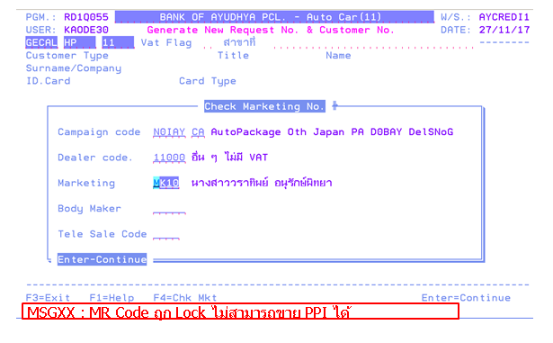

3.2 กรณีที่มีชุดเต็มเข้ามา แล้วระบบจับได้ว่าเป็น Campaign PPI และ MR Code ถูก Lock ขอให้เมนู 1001/1602 สามารถคีย์และยืนยัน ข้อมูลได้ โดยระบบจะแสดงเพียง Warning message
เป็น In case no life license : “ไม่มีบัตรนายหน้า ไม่ให้ขาย PPI”
In case expired license : “บัตรนายหน้า ไม่ให้ขาย PPI ”
ที่หน้าจอ โดยไม่ Lock การยืนยันข้อมูล
*** Detect the date of expiration by matching with field “Marketing date time”

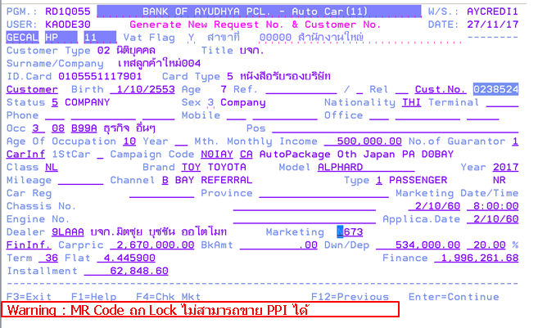
3.3 กรณีที่มีการ Change Campaign (ทั้งก่อนอนุมัติ และหลังจากที่อนุมัติแล้วมาขอ Re-open) จาก Normal ไปเป็น PPI ขอให้ระบบตรวจสอบว่า MR Code ถูก Lock หรือไม่ หาก Lock จะไม่สามารถ Confirm 1321+F7 (Finance Detail) ที่หน้าจอ Auto package ได้ ขึ้น Error message
เป็น In case no life license : “ไม่มีบัตรนายหน้า ไม่ให้ขาย PPI”
In case expired license : “บัตรนายหน้า ไม่ให้ขาย PPI ”
และไม่สามารถ Approve ได้
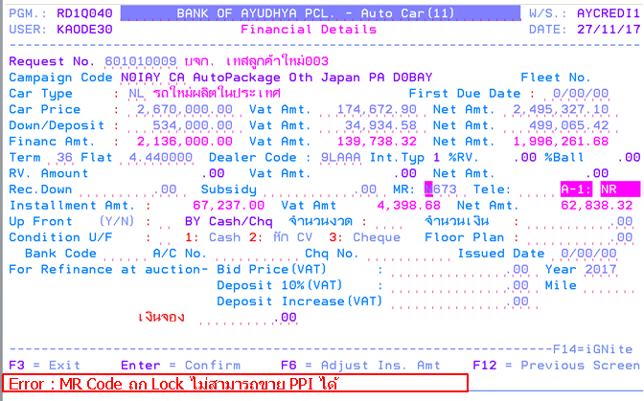

3.4 กรณีที่ไม่สามารถออกเลขคุมได้ CA จะทำการส่ง SMS incomplete ผ่านระบบ iDoc ซึ่งจะต้องทำการเพิ่ม SMS Code “IN23” ไม่มี/หมดอายุใบอนุญาตประกัน
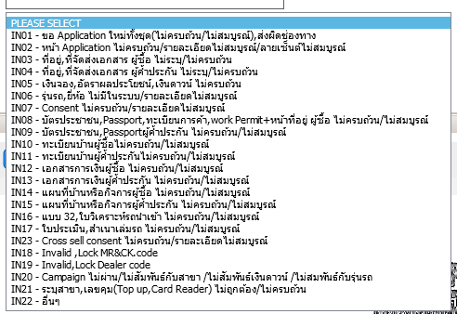

3.5กรณีที่มีการออกเลขคุมแล้ว จะทำการ cut off เงื่อนไขการอนุญาตให้ระบบสามารถ Process ต่อไปหรือไม่ ด้วยเงื่อนไขอย่างไร ขอหารือเพิ่มเติมกับ Project owner and IT

3.6 กรณีที่มีการ Lock Approve ตามข้อ 3 ที่มีเลขคุมแล้ว
ขอแจ้ง Sales ด้วย Pending Code = P42 “ขอเอกสารเพิ่มเติมอื่น ๆ ตามที่ระบุใน notepad”
โดย CA จะทำการ Note รายละเอียดเพิ่มเติม ไปให้กับทาง MR
For All error message will be
เป็น In case no life license : “ไม่มีบัตรนายหน้า ไม่ให้ขาย PPI”
In case expired license : “บัตรนายหน้า ไม่ให้ขาย PPI ”

Insurance Pare
4. เมนู 1211 เลือก Type 6

\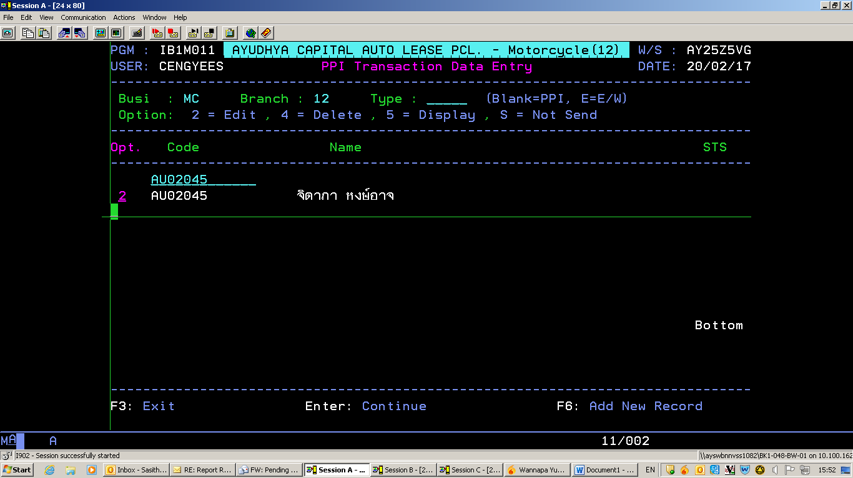
ให้ระบบเช็ค วัน MKT Date time เทียบกับ ใบอนุญาต MR ถ้าไม่ ACTIVE ให้ lock ไม่ให้ confirm
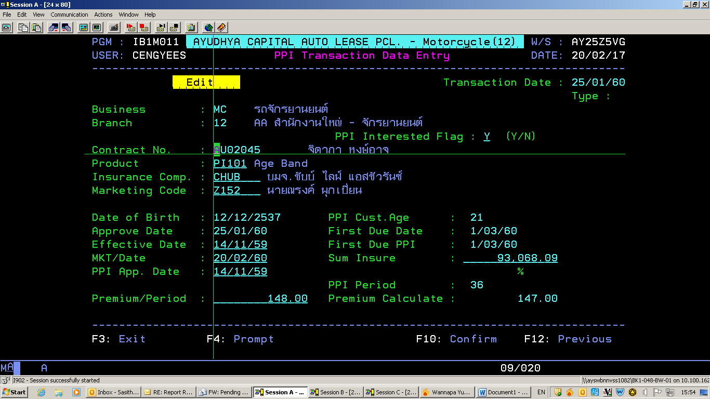

And Send notification to MR via ibuddy

In case no life license : “ไม่มีบัตรนายหน้าประกันชีวิตไม่สามารถขายประกัน ”
In case expired license : “บัตรนายหน้าประกันชีวิตหมดอายุ ไม่สามารถขายประกัน ”

5. Detect Report
For recheck MR who is no or expired licenses but try to sell PPI but not success by monthly for checking lost opportunity
By check 2 points
SG package : Incomplete on CA
ML/SG – CV : IN23 Incomplete on 1816, 1006 and 1675

Security and Capacity Requirements
[There is no security and capacity requirement.]

System impacts

Database impacts

Data Structure Change
[Refer to data structure change ex. Length change, add new field] (If any)

Data Conversion
[Refer to data conversion document] (If any)

Parameters impacts
[Perform while parameter setting has to be changed]

Communication impacts

Interface requirements
[In case of system interfacing, the detail of this area must be provided]

Infrastructure impacts
[Perform impact in term of bandwidth, capacity, LAN/ WAN, file loading/ transferring]

Other related platform impacts
[List other related platform]

General Consideration

Physical/ Layout Requirement
[Cell design, floor plan change]

Equipment and tools Requirement
[Hardware, software, phone, port]

Human Resource consideration
[New hired resource]

Training Requirements
Training Need | Training Program

Disaster Recover Plan/ Business Continuity Plan/ Crisis Management Plan
[Refer to DRP document of infrastructure team]

FMEA/ Risk Analysis

This section identifies risks associated with the high level design.

No. | Risk | Cause | Rating | Mitigation Strategy

Security Risk Analysis

A security risk analysis should be undertaken with the Security team at this point. The objective is to identify the key AYCL security requirements that apply to this project.

Evaluation Criteria | Examples | Potential Risks
IT Security Policies
IT Security Access & User Authentication
System Security Monitoring
Remove Access
Encryption

Financial business case
[An updated financial business case must be provided at this time]

Glossary of Terms

Glossaries | Definitions

Appendix A

ACCEPTANCE CERTIFICATE (AYCAL)

Company Name : Ayudhya Capital Auto Lease

Project : Project Name

Date : Signoff Date

Type | - Proposal  - Plan  - Specification  - Other

As a key stakeholder of this project, I accept that this document defines my requirements for this project in terms of key deliverables, budget, timeframes, and constraints.

I understand and accept that I have a responsibility within the project to assist the Project Manager and team in undertaking the project as specified within this document, including the provision of resources identified.

* Mandatory signoff is highlighted in bold text
Key persons | Signature | Date
 | Signed: ____________________ | Date: __________________
 | Signed: ____________________ | Date: __________________
Somkiat Sirirungthananan  Krungsri Auto Credit and Operations Management Division | Signed: ____________________ | Date: __________________
Orathai Kosacarn  Krungsri Auto Operations - Credit Department | Signed: ____________________ | Date: __________________
Somchit Naungtongnim  Krungsri Auto Operations Credit - Auto BKK & R6 Section | Signed: ____________________ | Date: __________________
Thanuchaporn Khampang  Krungsri Auto Operations Credit - Support Team | Signed: ____________________ | Date: __________________
 | Signed: ____________________ | Date: __________________
 | Signed: ____________________ | Date: __________________
 | Signed: ____________________ | Date: __________________
 | Signed: ____________________ | Date: __________________

